

Exploring Color -- Artwork by Cathy Hirsh

In collections in the US and internationally, Cathy Hirsh’s award-winning work has been described as stimulating, energetic, eclectic, heartfelt, joyful, thought-provoking yet approachable.

A Resident Artist and Teacher with classes at Artists & Makers Studios, Hirsh’s work can be found on websites, in gallery venues, and in periodic solo and group shows. Her work spans landscape, floral, and abstract subjects in multiple media.

Always a painting enthusiast, she has been a full-time painter since 2003. Then, Hirsh, a vice-president leading a consulting practice for a computer firm, found herself without a role after a re-organization. Instead of seeking another position, she decided to take a break to pursue her interests in painting, gardening, and travel while considering next steps. She has never looked back.

Her travels have taken her to all seven continents, often painting on location. She is a Master Gardener and speaks to garden groups on art concepts related to garden design.
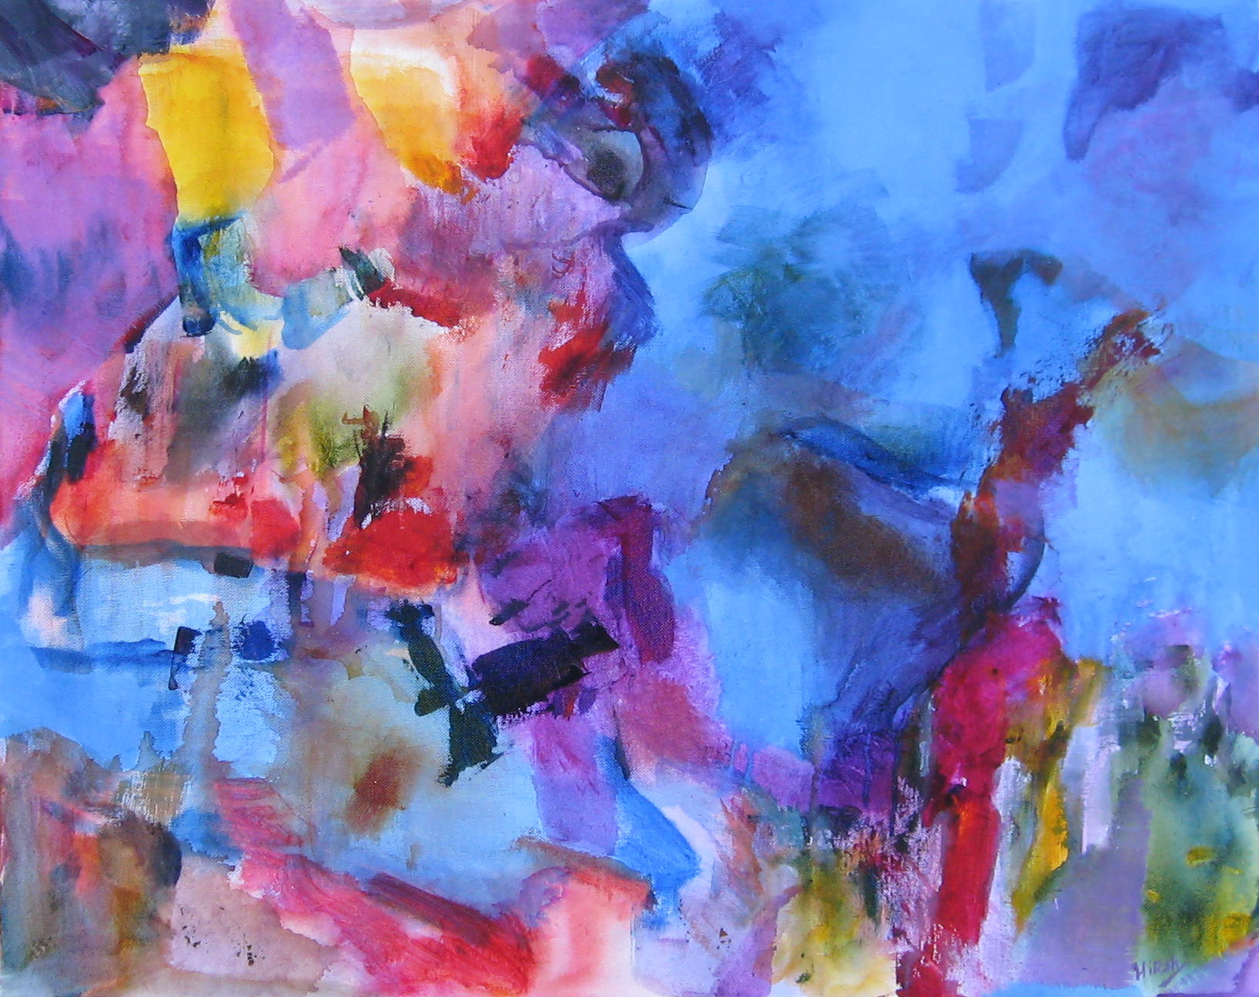
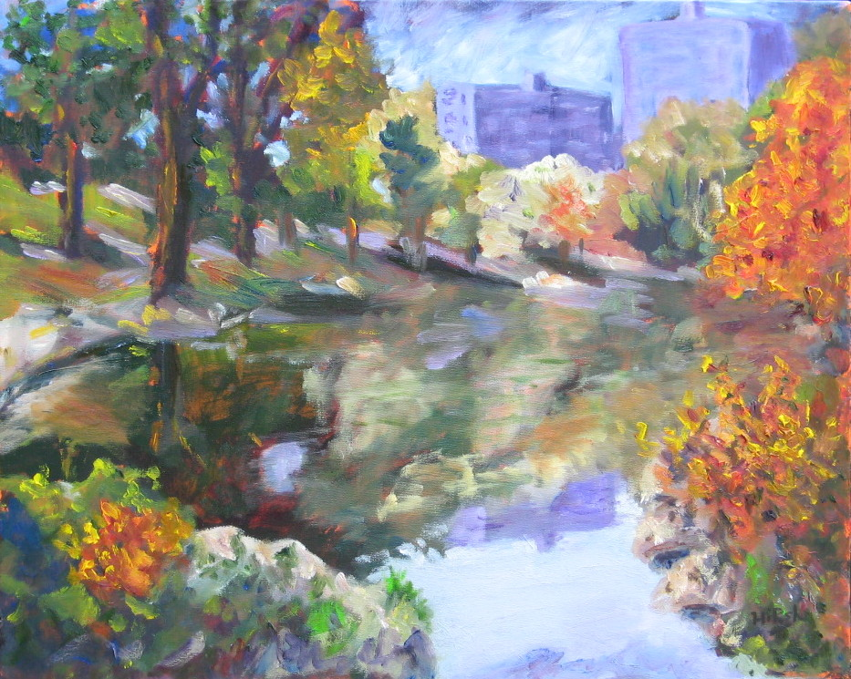

A member of various art organizations, Hirsh is a participating artist with Gallery 209, voted “Best Art Gallery in Rockville”. She managed the MAA Gallery in Westfield Wheaton mall from 2010 to Sept 2016 when the gallery closed. She was president of MAA 2010-2013.

She is currently the Curator of the Guest Gallery for Artists and Makers Studios, selecting and managing its monthly shows.

A native Californian, Hirsh lived in Ohio and New York before settling in Maryland outside Washington, DC.

About her work, Hirsh says, “Sometimes painting can seem magical as the piece seems to paint itself, capturing what I’ve imagined directly and simply. Other times, it can be a real struggle, whether it’s because of the subject, a new technique, or simply being outside fighting weather and insects!”

Further information at www.HirshStudio.com. Contact: CathyHirshArtist@gmail.com.

